**‘Romancing the Balance Sheet’ by ‘Dr Anil Lamba’ Summary**

**-Muhammad Anshad P A**

**-Roll no : 36**

**-MCA**

* **Who is a finance person ?**
* **someone who specializes in managing money and financial matters for individuals, businesses, or organizations.**
* **What is Finance Management ?**
* **Finance management is the ability on the part of every individual in the organization to understand the financial impact on the organization’s bottom line of every action taken.**
* **Many of us wrongly call People sitting in the Accounts Department as Finance. They are doing a postmortem they don't generate profit they just calculate the profit.**
* **Should we call the actions that generate profit as finance management or should we call the actions that calculate profit as finance management ?**
* **Profit and Loss Account :**

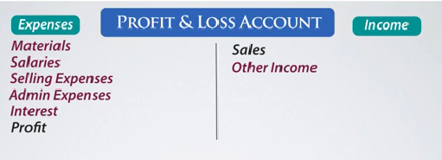

**A profit and loss account is made to find out whether the organization has made a profit or a loss**

* **How do you know are you making profit out of it?**
* **Do you think is possible for me to walk into an organization, look at the quality of infrastructure look at the number of people working over there see the level of business and conclude it's a profit-making organization .**
* **Truth is even if I am the owner of this business I will not know whether my organization is making profits or not until and unless somebody prepares and hands over to me a financial statement called profit and loss account.**
* **Since profit is not an obvious figure somebody needs to compile a whole lot of information and present it in the form of the statement.**
* **when do we say somebody has made a profit ?**
* **where the income of the organization happens to be greater than the expenses.**
* **An accountant will make the Profit and Loss Account in a ‘T’ format that is the right hand side with all the ‘Incomes’ and left hand side with ‘Expenses’. If the right hand side (income side) is greater than expenses you made a profit and if expenses are greater than incomes you made loss .**
* **why is profit listed on the expenses side ?**
* **To ensures the accounting equation (Assets = Liabilities + Equity).**

**Profit means your income was more than your expenses.**

* **In the final step, to balance everything out, the profit is shown as an "expense" to zero out the account and prepare it for the next period.**
* **BalanceSheet :**

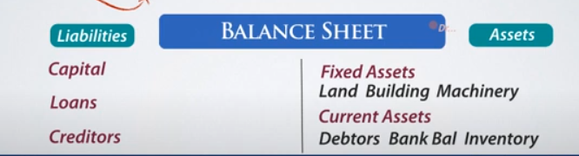

**Balance sheets list out ‘assets’ and ‘liabilities’.**

1. **‘Assets’ : two types of assets .**
   1. **Fixed Assets. Eg: Land , Building , Machinery etc..**
   2. **Current Assets. Eg: Debtors , Bank Balance,Inventory.**
2. **‘Liabilities’ : Means what you owe. what you have borrowed.**
   1. **Capital.(is the contribution made by you.Eg : equity)**
   2. **Loans.**
   3. **Creditors.**

* **Expenses Vs Assets:**

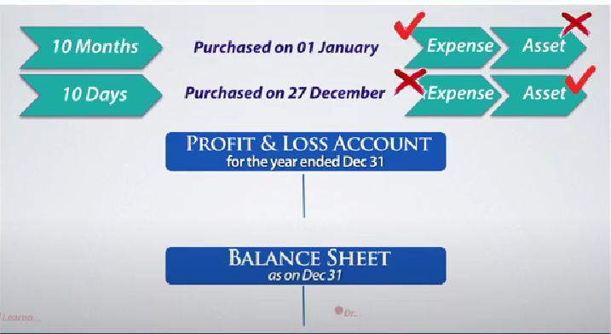

* **An asset is a business resource that offers economic benefit to the business in the future.**
* **An expense is a resource that the business has already consumed during the operations of the company for a specific accounting period.**
* **What is profit ?**
* **Profit = Income- Expense.**
* **Expenditure Vs Expense:**

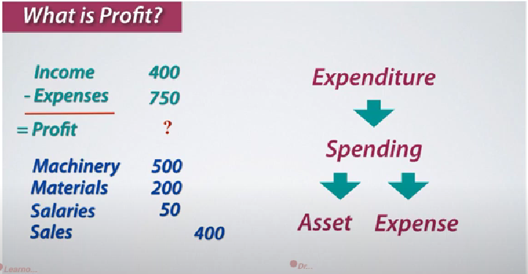

* **Expense is a subset of Expenditure .**

